***GParted Exercises***

**EXERCISE 2 → Recreation of a partition table in a 5GB disk**

For this exercise we will use the virtual machine created in the previous exercise, but this time we will add one more hard disk, this time of 5GB.

(As we did before, we only show some of the most important screenshots of its creation).

HARD DISK CREATION

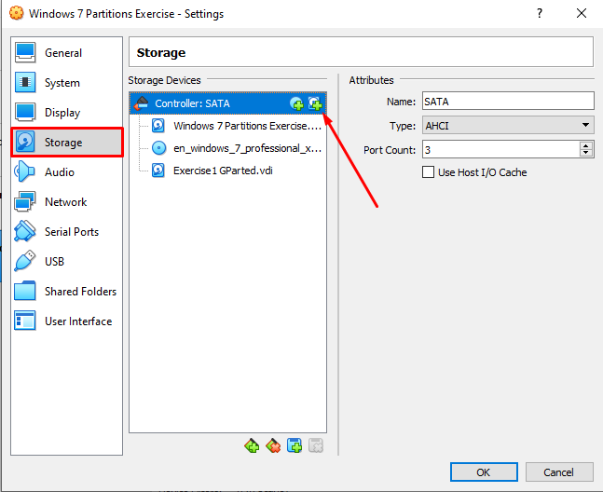

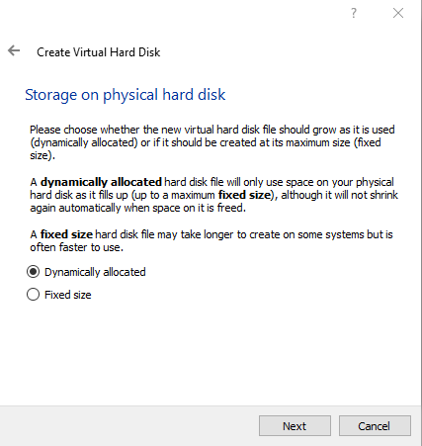 

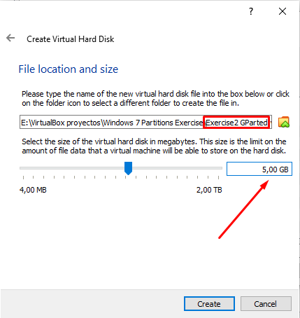

PARTITIONS

To be able to make the partitions needed, we have to change our ISO file from the one we had (in this case Windows 7) to DRBL, from where we will use “GParted”.

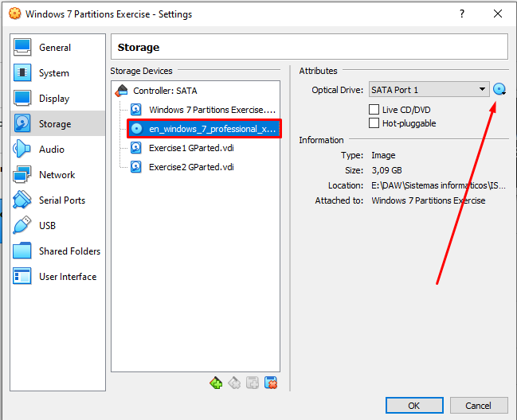

The process will be the same as in exercise 1. We will choose the default options by pressing “Enter”:

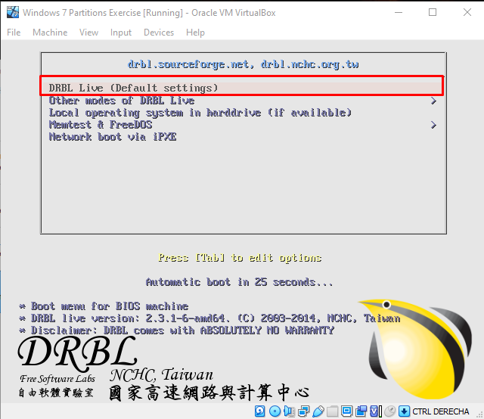

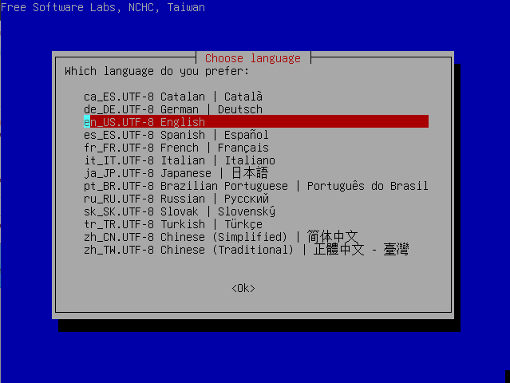

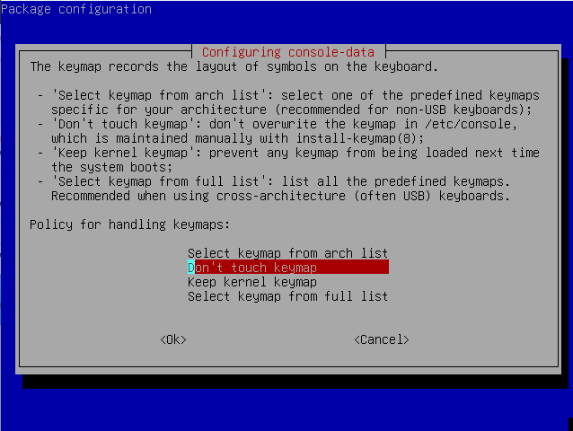

In this one we will press “1”, “Enter”, choose the resolution we want, type its number and press “Enter”. For the rest options (shown in the following pictures) we will just press “Enter”.

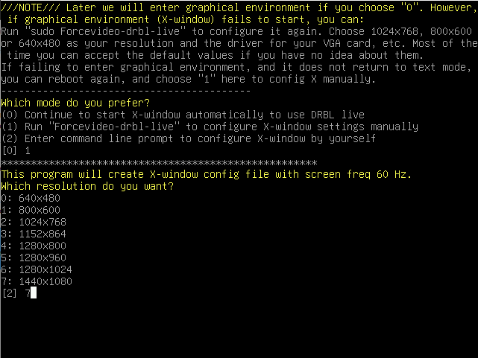

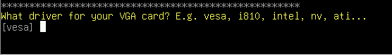

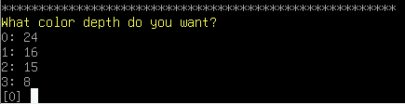

When everything is finished, we will open “GParted” and make sure we select the disk we want, in this case “sdc”.

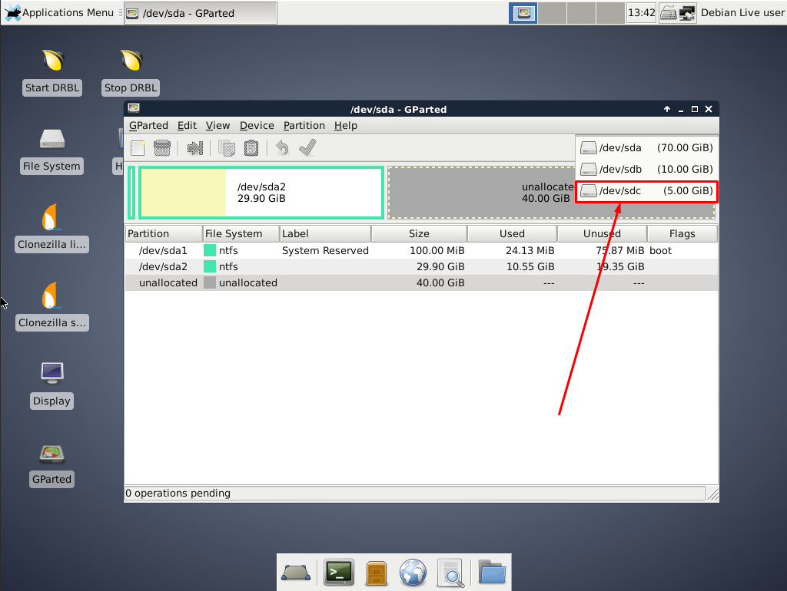

As we did in the first exercise, we will make an msdos (MBR) partition table and do the following:

* A FAT32 primary partition of 1GB, called “ONE”.

(**)The exercise asks for a FAT16 file system, but, as we said in class, a FAT32 would work for this exercise.

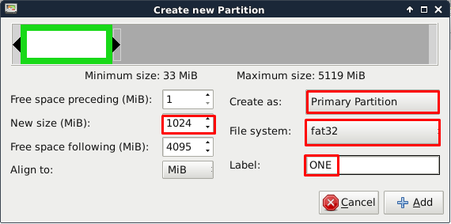

* An extended partition of 3GB (we should call it “TWO”, but the names of extended partitions are not shown, so we can just leave it empty).

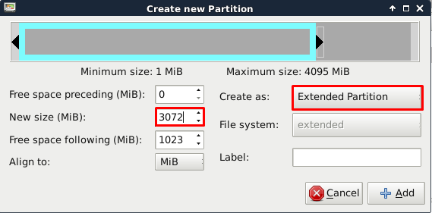

* Inside the extended partition we have just made, a logical NTFS partition of 1GB, which will be named as “FOUR”.

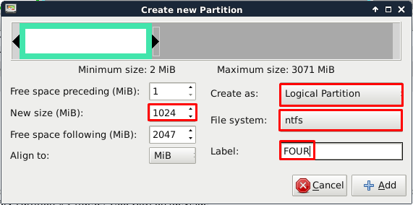

* Again, inside the extended one, a logical EXT4 partition of 1GB, named “FIVE”.

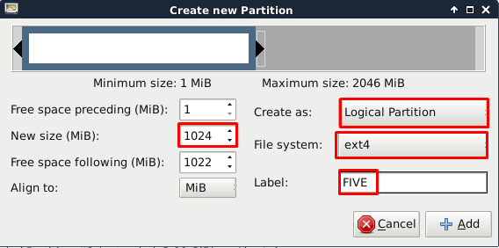

* Now, the last partition inside the extended one, a FAT32 logical one (called “SIX”).

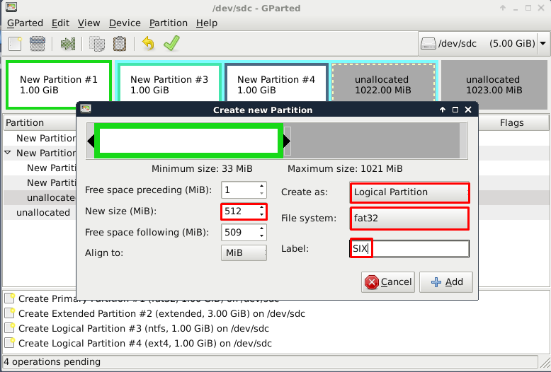

* Finally, the last partition we will create (outside the extended partition) will be a FAT32 primary one of 1GB, named “THREE”.

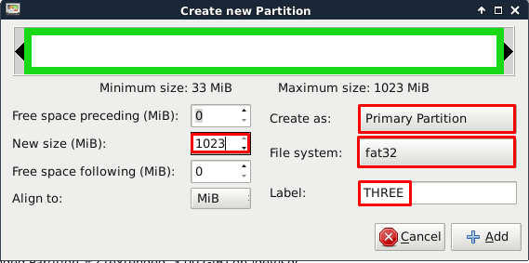

This is how they must appear in “GParted”. If it is like this, press the “check” symbol (✅) to confirm your partitions and shut down your machine.

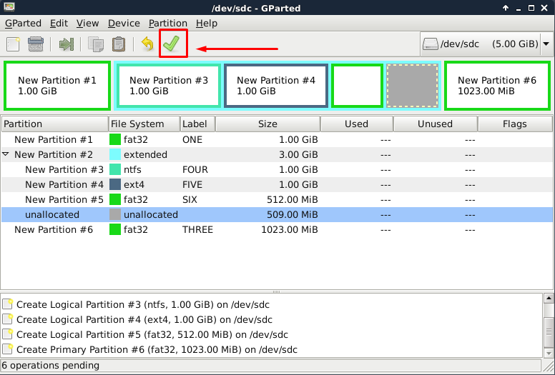

Finally, we will change our ISO file again to start our machine with Windows 7. When started, we will search in “Disk management” in the Windows menu (as we did in the previous exercise) and click “Create and format hard disk partitions” to be able to see all our partitions.

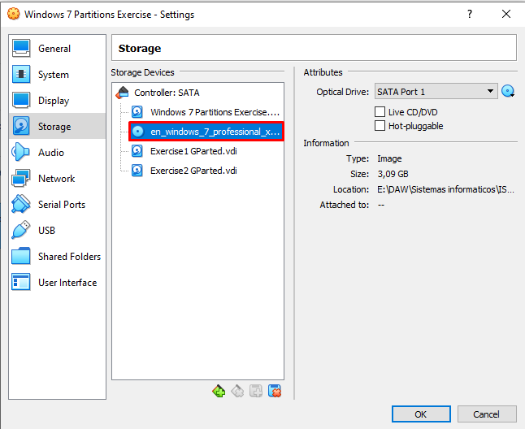

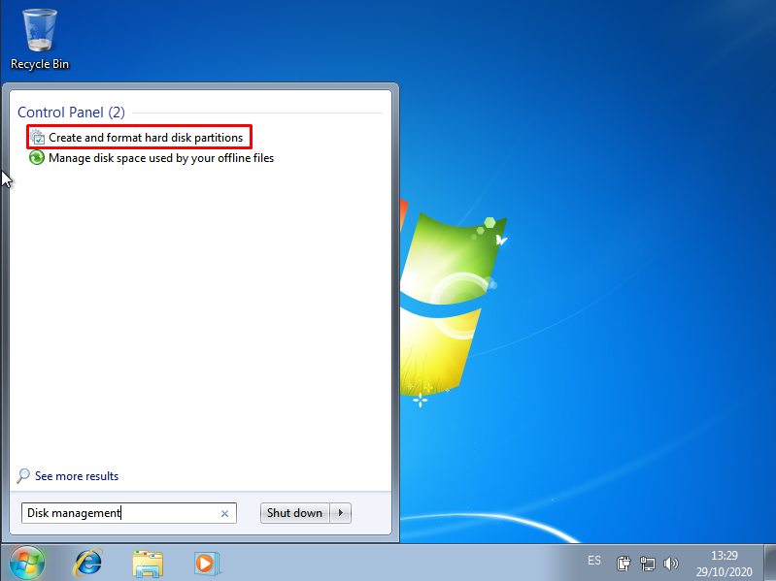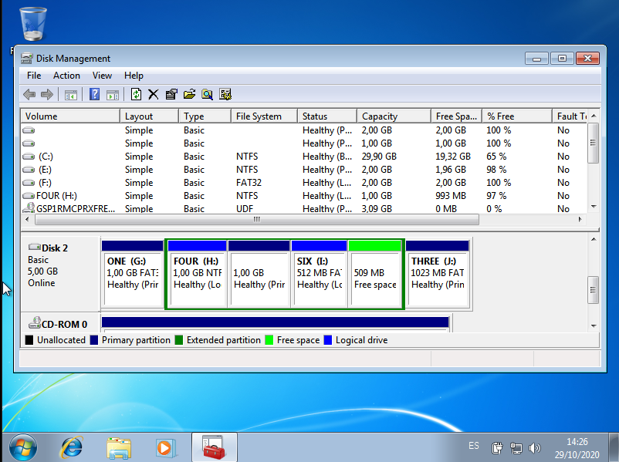

If your table is like this, you have finished with your partitions!

Questions:

* How does GParted name the new hard disk?
  + It names it as “sdc”, meaning “sata disk c”. This means our disk’s port is SATA and that it is our third unit (c).
* List all the partitions you have created, indicating type and file system:
  + **Partition “ONE ” →** Primary // FAT32(**)
  + **PARTITION “TWO”**: → Extended
* **PARTITION “FOUR”**: → Logical // NTFS
* **PARTITION “FIVE”**: → Logical // EXT4
* **PARTITION “SIX”**: → Logical // FAT32
* **PARTITION “THREE”**: → Primary // FAT32

**ALFREDO PUERTA GALLEGO DW1E**